Cybersecurity Progress Report

Jesse Villanueva, Hayden Flagg, Pierce Peterson, and Anthony Quintero

Advisor: Dr. Cavalcanti

**Goals**

For our project we chose cybersecurity with the goal of creating 2 servers. A good server that was safe, secure, and impenetrable. The second server called sad server that was vulnerable, so we could hack it using methods like SQL Injection.

**Progress**

The two websites work as intended so far. They allow users to both login and signup. Cr. Cavalcanti suggested we use Black Arch for hacking our website. While it couldn’t hack our good server like intended it also couldn’t hack our sad server. We tried SQL Injection and kept getting no query string as an error.

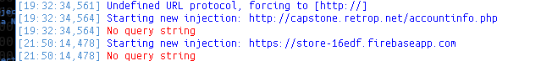

Although we found another way to alter our website. Our sad server lists products that are available for sale and we were able to change whether the items were available or not through editing the URL of the accounts page.

**Future**

Our goal is to give the websites more pages and information, allowing for more vulnerability on our sad server. We will also get the SQL injection working so we can access our database and alter it. Other types of attacks that have been discussed are XSS or cross site scripting and DoS or Denial of Service.